Resources for Hot Drinks for Health Saturday 12th of December 2020

Important Points to note:

Boiling water is used when making the hot drinks in this zoom presentation, so therefore caution is advised at all times when removing saucepans of very hot or boiling water from the hob and also when pouring boiling/very hot water into heatproof cups or heatproof glasses. Care is also required when using knives to chop and peel ingredients. Care is also required when using a grater and a blender.

This zoom is only recommended for individuals aged 16+ with a responsible adult supervising at all times.

Please ensure that your hot drink has cooled to a drinkable warm temperature before you drink it, so as not to scald the lips/mouth/tongue.

Rosemary Milk
Ingredients:
250ml milk
4-6 inch stem of fresh rosemary
tsp of honey (optional)
Method:
- Break the rosemary into 3 or 4 pieces.
- Put 3 pieces into a saucepan and add milk.
- Bring slowly to the very gentle boil, and then simmer for 5 minutes while stirring continuously (do not boil).
- Press the rosemary against the side of the saucepan to extract the juices. Strain carefully into a heatproof glass/mug. Discard the rosemary.
- Drink whilst still warm and with some rosemary floating on top (if desired) and stir in the honey (if using). Serves 1.
_____________________________________________________

Marmalade and Ginger Tea
Ingredients:
½ inch fresh root ginger
tbsp. thin-cut orange marmalade

Method:
- Peel and carefully grate the ginger. Put ginger into a heatproof mug/glass and carefully cover with boiling water.
- Leave for 5 minutes and carefully strain. Add the marmalade and stir until dissolved. Drink while still warm. Serves 1.

Berry Punch
Ingredients:
90g frozen (or fresh) mixed berries
¼ inch fresh ginger root
1 cinnamon stick

Method:
- Put the berries in a saucepan.
- Carefully peel and bruise the ginger but leave it in one piece and add to the saucepan.
- Add 200ml of water to the saucepan and then, bring slowly to a simmer and continue to simmer for ten minutes.
- Carefully remove ginger and strain the punch through a sieve, pressing the fruit to extract all the juices. Warm up again (carefully) if necessary. Drink while still warm and with a cinnamon stick in the mug/glass. Serves 1.

Hot Banana Smoothie
Ingredients:
1 small banana (carefully chopped)
200ml milk
60ml live yoghurt
1 level tsp of cocoa powder and ground cinnamon

Method:
- Put milk, chopped banana and yoghurt into a blender and blend until very smooth.
- Pour into a saucepan and carefully heat until just simmering (do not boil).
- Use a whisk or fork to stir up a froth.
- Pour carefully into a heatproof mug/glass. Sprinkle cinnamon and cocoa powder on top. Drink while still warm. Serves 1.

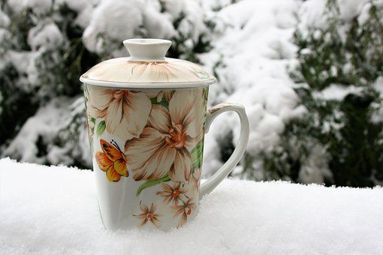

Turmeric Milk
Ingredients:
250ml of coconut milk
½-1 tsp ground turmeric
pinch of black pepper
¼ tsp of ground cinnamon
honey (optional)

Method:
- Put all ingredients into a saucepan over medium heat and carefully bring to a simmer.
- Simmer for 10 minutes, stirring occasionally.
- Carefully pour into a heatproof mug/glass.
- Stir in honey (if using). Drink whilst still warm. Serves 1.

